Assignment #4
Visual Design Critique

Molly Brunner

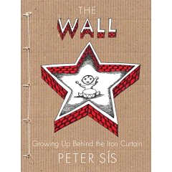
Peter Sis creates a fascinating memoir and historical story about his childhood in Cold War–era Prague, Czechoslovakia – revealing elements of what life was like behind the Iron Curtain in his book, THE WALL.

Visual Elements
The cover illustration is simple, yet powerful and effective. A young child is playing within the confines of a red brick star shaped wall. The shadow within the star (a familiar shape) conveys a sense of depth, as if the child is hidden, his innocence lost inside the unyielding walls.
In addition, the arrangement of pictures and words is such that one’s attention is drawn to the red star in the center of the page, and then pulls your eye up to the word, “WALL”. The flow is enhanced by the star and the word “WALL” both being of red brick, with a flat white top, creating a three-dimensional effect. The star wall and wording are aligned vertically, pulled together with the vertical line of knotted string on the left side.
There is a sense of balance to this image. The star is the largest item on the page and centers and balances the wording above and below it. The knotted string on the left side of the page creates an effective informal balance. The colors are powerful in their simplicity – things are black and white under Communist red, and so stand out against the soft light brown background.
The effect of height of the red bricks and the textured cardboard look of the background invites one to touch the photo, adding to the appeal of the image.

Text Elements
The use of different fonts, style, space and size are effective in this image. The title “WALL” is emphasized so the three-dimensional effect and larger size makes it stand out. In addition to the size, the spacing is such that the words are easy to read. Off-white is the color used for the remaining words that contrasts the brown background color. The effect is subtle, which seems intended in order to highlight the brick star and title name.
The subtitle uses a different font than the title, of course, and the author’s name, but almost seems to get lost on the page due to the thinness of the lines. The subtitle is the only text that is not capitalized, which as it is a longer phrase, is appropriate. Personally I found the capital letters easier to read, and the lower case subtitle less legible – but that could be due to the font and the tighter spacing of letters of the subtitle.

Appeal and Opinion
As previously indicated, I found the cover of this book visually appealing and powerful. The arrangement of the wording and the picture catch your eye and are balanced, drawing one both into the center of the star as well as vertically up the page. The colors are simple but compelling as they tell their own story about Communism. The texture of the brick wall and background further convince the reader of the restrictive and harsh times under Soviet rule. These effects combine to invite one in to discover what his life behind the Iron Curtain was like. The only piece I would change would to make the subtitle a font that was a little thicker so that it’s more legible.

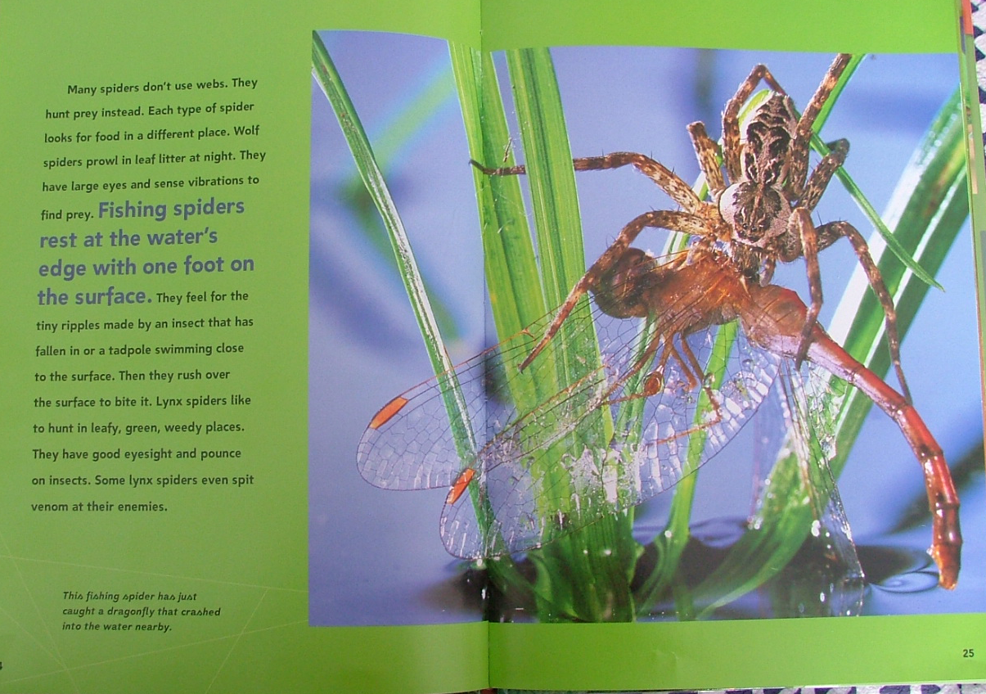
This picture does not do justice to the incredible photographic images taken from a page in the book SPIDERS by Nic Bishop (this photo was taken with my camera). The fascinating pictures of these amazing creatures, which have been around for more than 350 million years, would fuel anyone’s arachnophobia. The images were so striking I thought they would be fun to share and evaluate.

Visual Elements
The photo of this spider dominates two thirds of the double page, which meets the author’s intention of spotlighting this close-up shot, and immediately draws your eye it. The spider and his prey, darker in color, seem to be framed within, and contrasted with, the bright green leafy weeds.
The lines of the tall weeds, the dragonfly’s body and wings, and the spider’s legs seem to pull one into the slightly off-center main part of the photo. This effectively creates an informal balance as well as vertically dividing the page into thirds. Although the upper left intersection is said to be the most dynamic position visually, Bishop does the opposite by emphasizing the upper right intersection, which is just as dynamic and is balanced with the text on the left third of the page.
Analogous colors, blues and greens, create a pleasant combination visually. These are “cool” colors so effective as the backdrop. The darker brown of the spider and its prey follows the figure-ground contrast, with the darker color showing up better on the lighter background. The colors themselves are so bold and vibrant they bring life to the page, and would be more appealing to children.

Text Elements
The figure-ground contrast is also utilized with the text. Black text contrasts sharply against the soft, albeit vibrant green. A darker shade of the analogous color blue stands out in contrast to the green, and is emphasized with the use of a larger size and bold font. One’s eye is drawn to that line of text, which intends to create the desire to read more. And I believe it succeeds in it’s intent.
In addition, a footnote is placed at the bottom of the page, framed within soft lines of webbing, also in black. After reading the other text, one’s eye follows to the bottom to read the description of the photo, and pulls you back to the photo again.
The text itself is large enough and contains expanded letter spacing allowing the words to be easily read. Legibility is enhanced with the use of lowercase letters.

Appeal and Opinion
All of the elements mentioned above come together to create an outstanding image in my opinion. The amazingly close-up shot gives a three-dimensional sense to the picture where one feels as if they could actually pick up the spider or touch the wing of the dragonfly.
The placement, size, color and spacing of the text complement and enhance the photo. If the text was not as strong in it’s own right, it would be overpowered by the image. The vibrant colored page frames the photo as well. I found this page to be appealing as an adult and I believe kids would be fascinated as well. I was not able to come up with anything I would change on this photo.

